Inhibition Boxes

Eva Reindl

6 4 2020

Key findings:

* 126 valid data
* DV: proportion of correct trials
  + Not normally distributed
  + Children (all age groups, mediansplit) above chance performance
  + 4-year-olds not better than 3-year-olds
  + Older children not better than younger children
  + Effect of age and trial number on success (no effect of testing location)

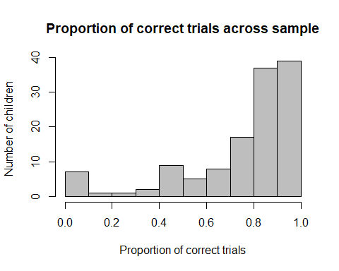 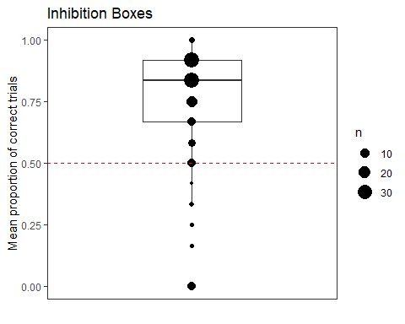

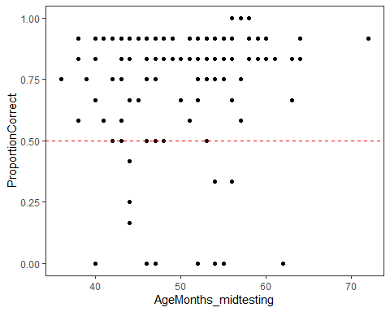 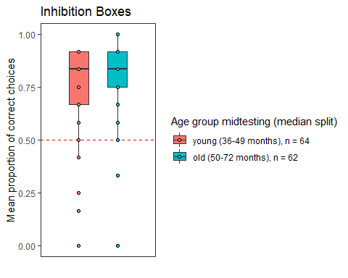

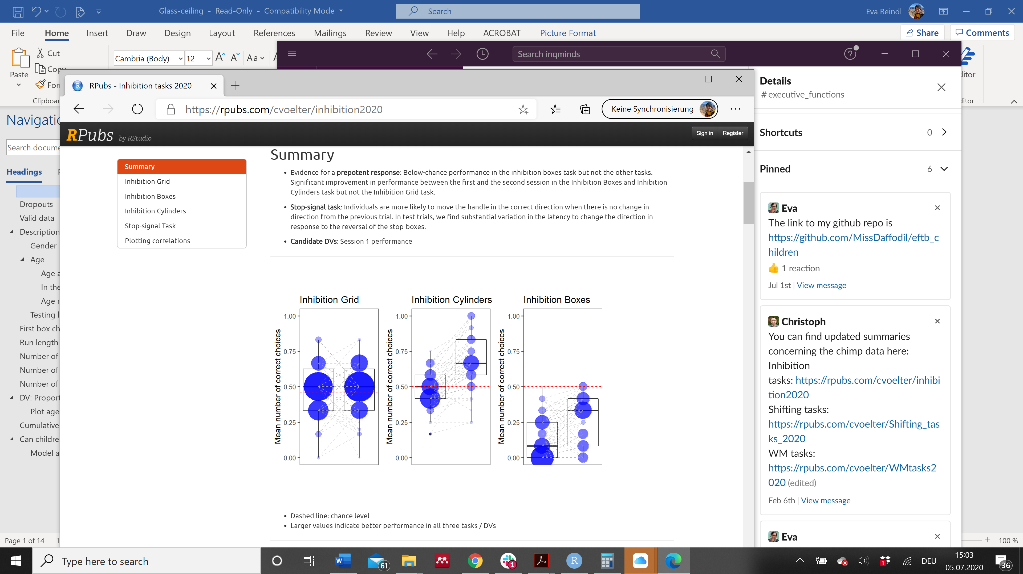Children (only 1 session) Chimps

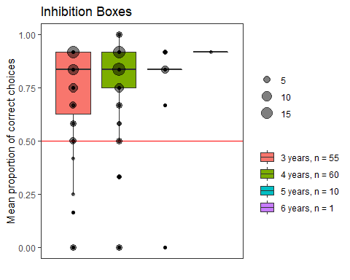

## [1] "R version 3.6.1 (2019-07-05)"

133 children are in the dataset.

# Dropouts

We have **7 dropouts**:

* 3x sticker was not visible (all female)
* 1 x child stopped after 3 trials (male)
* 1x in trial 9 saw egg in opaque box (female)
* 1 x stopped game after 7 trials (female)
* 1 x stopped game after 2 trials (female)

# Valid data

There are **126 valid cases** in the glass ceiling task.

We decide - also in line with our decisions for the rest of the tasks - that we include all children who have completed 75% of the trials, which is 9 trials or above. We find that none of the children in the dropouts fulfil this criterion, so the final dataset is still 126.

# Description of sample

## Gender

There are **67 females** and **59 males**.

## Age

### Age at the beginning of testing

At the beginning of testing, children included in the glass-ceiling task were on average 48.91 months old (SD = 6.96, range 36-70). There were 57 3-year-olds, 62 4-year-olds, and 7 5-year-olds.

### In the middle of testing

In the middle of testing, children included in the glass-ceiling task were on average **49.95 months old (SD = 6.94, range 36-72)**. There were

* 55 3-year-olds
* 60 4-year-olds
* 10 5-year-olds
* 1 6-year-old

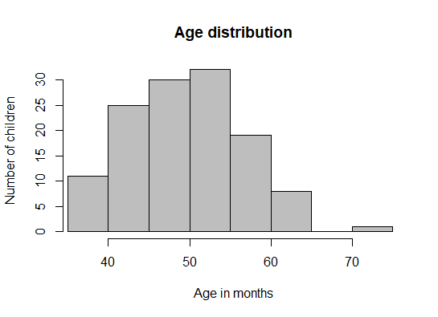

### Age mediansplit (based on entire sample)

There were **64 young** (35 f, 29 m) and **62 old** (32 f, 30 m) children.

## Testing location

There were 58 children from Edinburgh and 69 children from Fife.

* Edinburgh: M = 49.38 months (SD = 5.83, range 36-58)
* Fife: M = 50.44 months (SD = 7.77, range 38-72)

# First box chosen

**111 out of 126 children (88%) chose the transparent box first**, while 15 (12%) picked the opaque box first.

* 3-year-olds (n= 55): 51 (93%) picked transparent, 4 opaque
* 4-year-olds (n = 60): 49 (82%)picked transparent, 11 opaque
* 5-year-olds (n = 10): 10 (100%) picked transparent, 0 opaque
* 6-year-olds (n = 1): 1 (100%) picked transparent
* Young children (n = 64): 57 (89%) picked transparent, 7 opaque
* Old children: (n = 62): 54 (87%) picked transparent, 8 opaque

# Run length

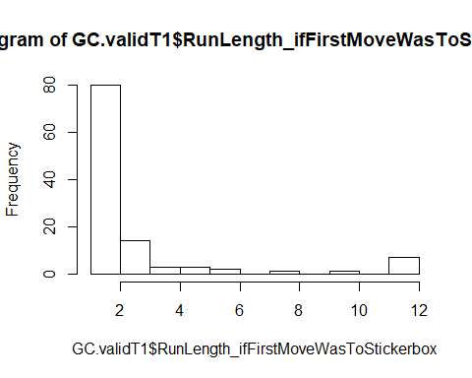

Out of the 111 children who chose a transparent box first, 68 children **(61%) then tried the opaque box in trial 2**. The remaining children had **run lengths of mostly 2 or 3 trials, but there were also 7 children who never tried the opaque box**. Mean run length was **2.48 (SD = 2.90, range 1-12)**.

* 3y: 2.70 (SD = 2.93, range 1-12)
* 4y: 2.28 (SD = 2.83, range 1-12)
* 5y: 2.40 (SD = 3.44, range 1-12)
* 6y: 1
* Young: 2.60 (SD = 2.81, range 1-12)
* Old: 2.35 (SD = 3.02, range 1-12)

# Number of correct trials

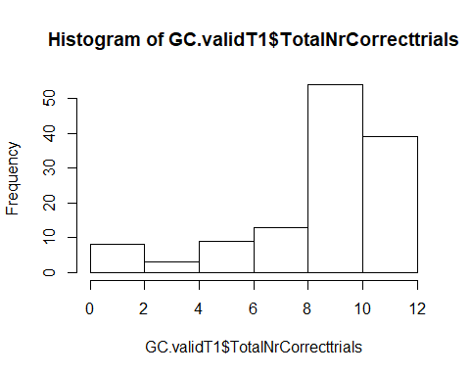

The average number of correct trials was **8.89 (SD = 2.86, range 0-12)**. The variable is not normally distributed, W = 0.741, p < .001.

* 3y: 8.54 (SD = 2.95, range 0-11)
* 4y: 9.15 (SD = 2.74, range 0-12)
* 5y: 9.00 (SD = 3.26, range 0-11)
* 6y: 11
* Young: 8.73 (SD = 2.82, range 0-11)
* Old: 9.05 (SD = 2.92, range 0-12)

# Number of errors

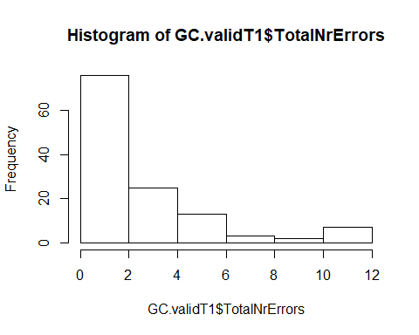

The average number of errors was **3.11 (SD = 2.86, range 0-12)**. The variable is not normally distributed, W = 0.741, p < .001.

* 3y: 3.45 (SD = 2.95, range 1-12)
* 4y: 2.85 (SD = 2.74, range 0-12)
* 5y: 3 (SD = 3.26, range 1-12)
* 6y: 1
* Young: 3.26 (SD = 2.82, range 1-12)
* Old: 2.95 (SD = 2.92, range 0-12)

# Number of mistakes after first reach to opaque box

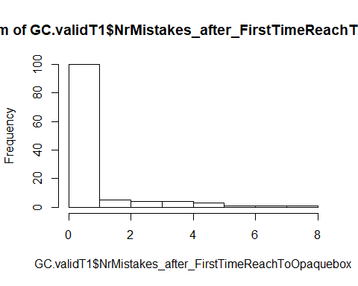

119 children (94%) reached to the opaque (correct) box at least once. For those children, the average number of mistakes after reaching to the correct box first was 0.97 (SD = 1.52, range 0-8). The variable was highly skewed.

* 3y (n = 52): 1.00 (SD = 1.69, range 0-8)
* 4y ( n = 57): 1.00 (SD = 1.49, range 0-7)
* 5y (n = 9): 0.67 (SD = 0.5, range 0-1)
* 6y (n = 1): 0
* Young (n = 61): 0.98 (SD = 1.59, range 0-8)
* Old (n = 58): 0.95 (SD = 1.47, range 0-7)

# DV: Proportion of correct trials



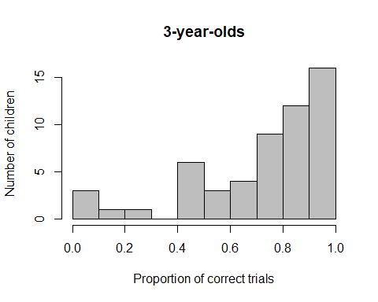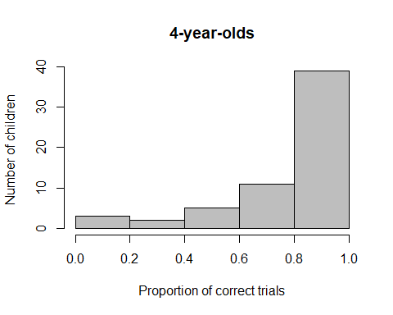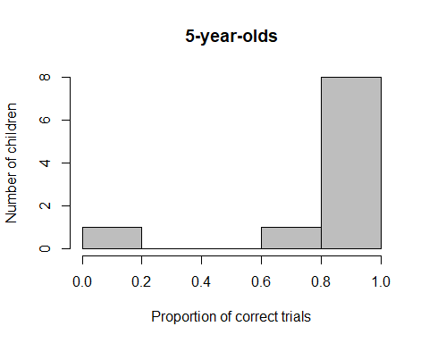

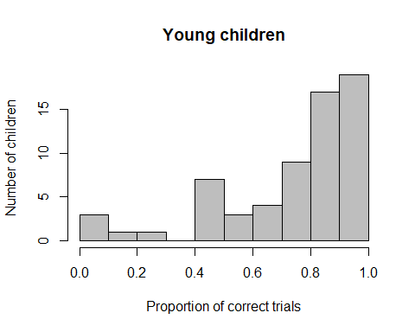 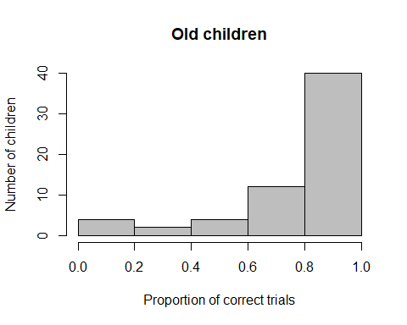

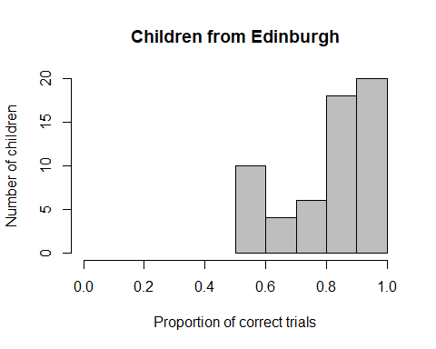 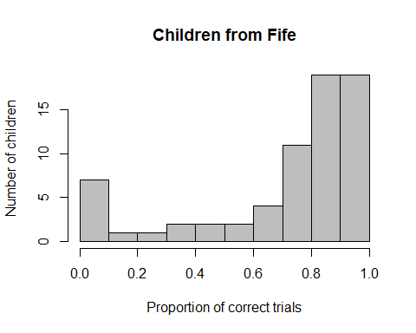

The mean proportion of correct trials was **0.74 (SD = 0.24, range 0-1)**. The variable is **not normally distributed**, W = 0.741, p < .001. Children’s **performance is significantly higher than what would be expected by chance (0.5)**, two-sided Wilcoxon test, V = 6121, p < .001.

* **3y: 0.71** (SD = 0.24, range 0-0.92), not normally distributed, W = 0.779, p < .001. Significantly above chance, V = 1087, p < .001
* **4y: 0.76** (SD = 0.23, range 0-1), not normally distributed, W = 0.727, p < .001. Significantly above chance, V = 1479.5, p < .001
* **5y: 0.75** (SD = 0.27, range 0-0.92), not normally distributed, W = 0.555, p < .001. At chance level, V = 45, p = .076
* **6y: 0.92**

**4-year-olds do not perform better than 3-year-olds**, one-sided Wilcoxon test, W = 1416, p = .090.

* Young: 0.73 (SD = 0.23, range 0-0.92), not normally distributed, W = 0.760, p < .001. Significantly above chance, V = 1496.5, p < .001
* Old: 0.75 (SD = 0.24, range 0-1), not normally distributed, W = 0.710, p < .001. Significantly above chance, V = 1591, p < .001

**Old children do not perform better than young children**, one-sided Wilcoxon test, W = 2165.5, p = .182.

* Edinburgh: 0.79 (SD = 0.14, range 0.5-1), not normally distributed, W = 0.841, p < .001. Significantly above chance, V = 1326, p < .001
* Fife: 0.70 (SD = 0.29, range 0-1), not normally distributed, W = 0.728, p < .001. Significantly above chance, V = 1771.5, p < .001

**Children from Edinburgh do not perform differently than children from Fife**, two-sided Wilcoxon test, W = 2234.5, p = .188.







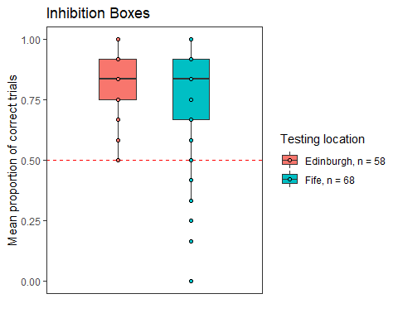

## Plot age as continuous variable against proportion correct



# Cumulative proportion correct

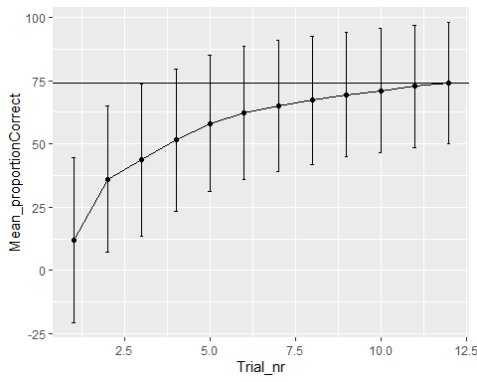

# Can children’s success be predicted by trial number, age and testing location?

#Full model  
res<-glmer(Trial_Correct ~ z.age.midtesting + z.Trial_nr + TestingLocation + z.age.midtesting:z.Trial_nr + (1+z.Trial_nr|ID), data=GC.valid, family = binomial)

Comparison against null model

Together, age, trial number, the interaction between trial number and age, and testing location can explain the data significantly better than a null model only containing the intercept, X2(4) = 116.11, p < .001.

**Effect of the interaction term**

There is no effect of the interaction term, X2(1) = 0.002, p = .960, so we remove it from the model.

New full model

res<-glmer(Trial_Correct ~ z.age.midtesting + z.Trial_nr + TestingLocation + (1+z.Trial_nr|ID), data=GC.valid, family = binomial)

The full model can explain the data significantly better than a null model only containing the intercept, X2(3) = 116.11, p < .001.

**Estimate of testing location**

Testing location cannot improve model fit, X2(1) = 2.617, p = .106, so we remove it from the model.

New full model

We include the non-transformed version of trial number

res<-glmer(Trial_Correct ~ z.age.midtesting + Trial.Nr + (1+Trial.Nr|ID), data=GC.valid, family = binomial)

Trial number and age can explain the data significantly better than the null model, X2(2) = 113.49, p < .001.

**Effect of trial number**

Trial number had a significant effect on children’s success, X2(1) = 108.7, p < .001.

**Effect of age**

Age had a significant effect on children’s success, X2(1) = 4.506, p = .034.

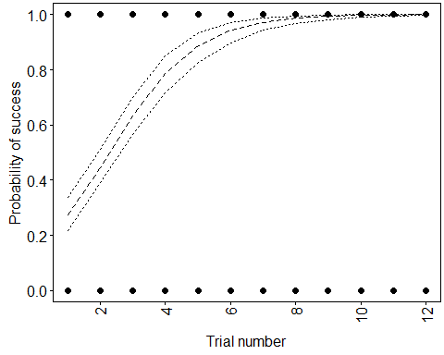

## Model assumptions

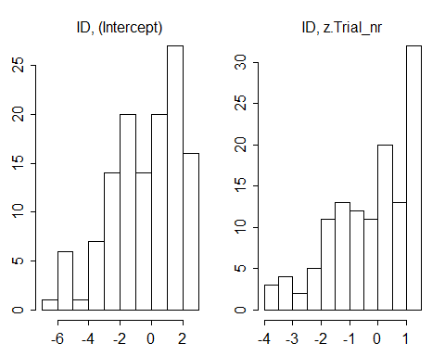

#collinearity  
vif(xres)

## z.age.midtesting Trial.Nr   
## 1 1